Subject Name: STRUCTURAL ANALYSIS -1

Prepared by (Faculty (s) Name): MOHAMMED HANEEF

Year and Sem, Department: II-II CIVIL

Unit-I: (ANALYSIS OF PERFECT FRAMES )

Important points / Definitions:

- Definetrusses
- Truss is a structure composed of slender members (two-force members) joined together at their end points. Joints are modeled by smooth pin connections.
- What are the different types of roof trusses?
- Different types of roof trusses are: King Post Truss. Pratt Truss. Queen Post Truss. Howe Truss. Fan Truss. Quadrangular Roof Trusses. Parallel Chord Roof Trusses.
- What is the purpose of a truss?
- The purpose of a truss is to distribute the load through all the members.
- What is a truss element?
- The truss transmits axial force only and, in general, is a three degree-of-freedom (DOF) element
- What is the difference between a truss and a beam?
- Trusses are used only when it is intended to transfer the loads through axially loaded elements (No bending takes place)
- What is method of joint?
- The method of joints is a way to find unknown forces in a truss structure. The principle behind this method is that all forces acting on a joint must add to zero
- What is a determinate truss?
- A truss is considered statically determinate if all of its support reactions and member forces can be calculated using only the equations of static equilibrium
- What is indeterminacy degree ?
- Degree of static indeterminacy = Total number of unknown (external and internal) forces. - Number of independent equations of equilibrium.
- What is static indeterminacy?
- Perfect frames are the frames which can be analysed to get the internal member forces and external support reactions by using the three conditions of static equilibrium. A simple example of a perfect frame is a triangular frame which is formed by joining the three member with the help of three joints.
- In statics, a structure is statically indeterminate (or hyperstatic) when the static equilibrium equations are insufficient for determining the internal forces and reactions on that structure.

- 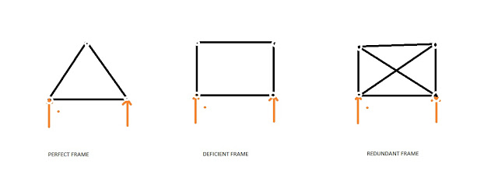

To check if the frame is perfect/determinate or imperfect remember the following:
For perfect frame:
m = 2j -3
m=nos. of members in a frame
j = nos. of joints.
For a triangular frame m =3 and j = 3 so when we put these values in the equation above we get both the sides equal so, a triangular frame is a simple example of a perfect frame.
Now if m<2j-3 then the frame is called a deficient frame and the frame is unstable, i.e. the frame will deform if the external load is applied.
And if m>2j-3 then the frame is redundant. It is stable but we can not analyse the frame with the help of the conditions of the static equilibrium. and the difference between the m and 2j-3 is know as the redundancy of the frames.
For determinate frames/perfect frames, we can easily find out the external support reaction using the three equations of static equilibrium. To determine the forces in the members of the trusses,
I.SHORT ANSWER QUESTIONS [2M]

- Differentiate between the perfect, imperfect and redundant pin jointed frames ? (dec 2015)
- Explain briefly about trusses? (may 2016)
- Define the following term: a) Perfect frame? b) Imperfect frame? (dec 2016)
- Define the following term: a) Redundant frame? b) Deficiency frame?(dec 2017)
- Classify trusses based on geometrical configuration and arrangements of bars? (may 2017)
- Classify trusses based on stability and determinacy concept? (dec 2018)
- Evaluate the determinate pin jointed frames by method of joint, method of section for horizontal and inclined load? (dec 2018)
- Analysis of determinate pin jointed frames using method of joint, method of section for vertical load? (2016)
- What are the assumptions used to determine the bar force in truss?(may 2016)
- What is determinacy of a truss? (dec 2017)

II .LONG ANSWER QUESTIONS [5M]

- Find the force acting in all members of the truss shown in Figure.(may 2015)

  - 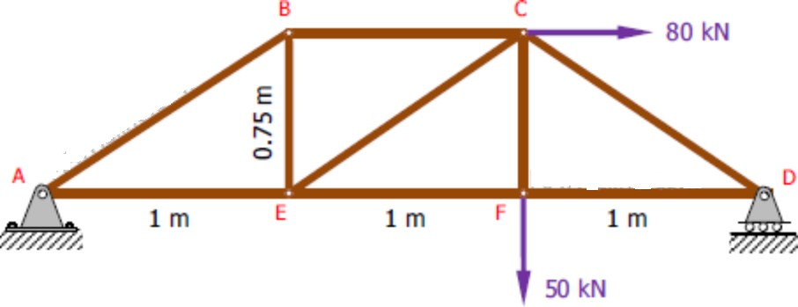

- The structure in Fig. T-02 is a truss which is pinned to the floor at point A, and supported by a roller at point D. Determine the force to all members of the truss. (may 2015)

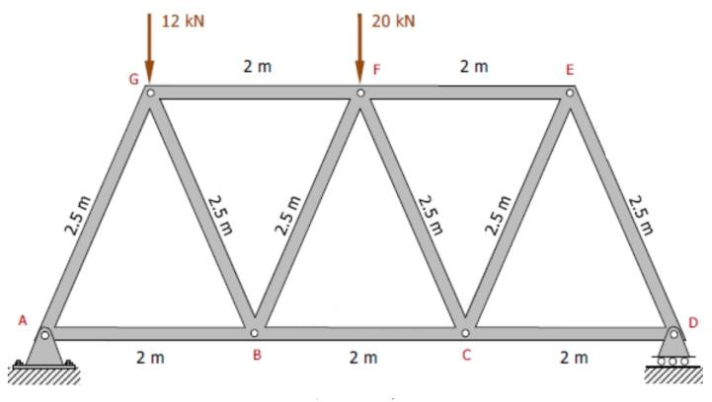
- Compute the force in all members of the truss in Fig.
  - 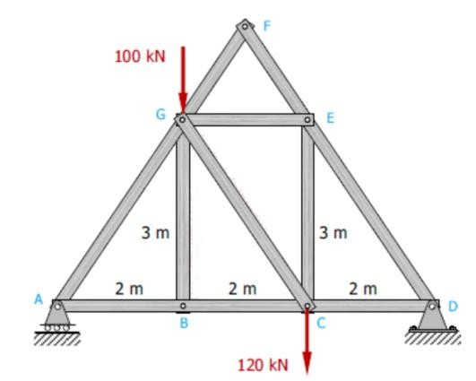compute the forces in all members by section method

  - 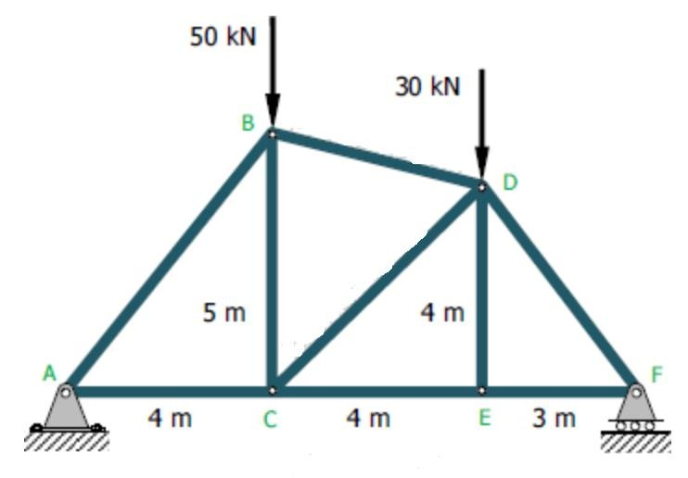

- Determine the forces in the members of the roof truss shown in Fig. (dec 2018)
- .

  - 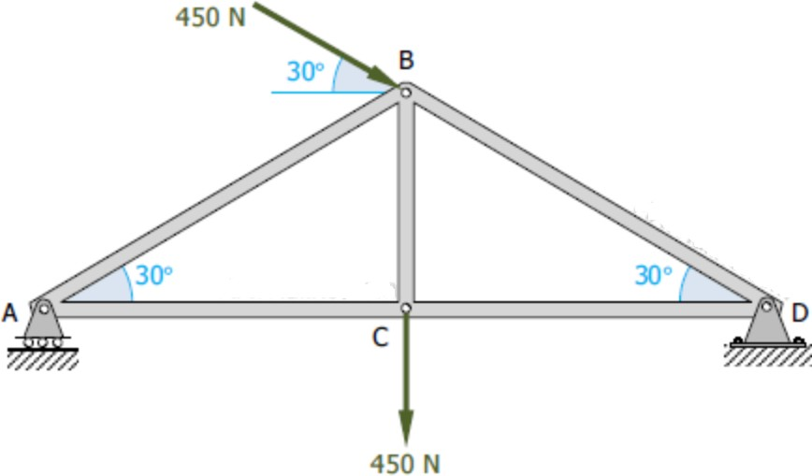

- Determine the forces in the bars EF, DF and DH of the truss as shown in figure below by using method of sections ( may 2016)
- 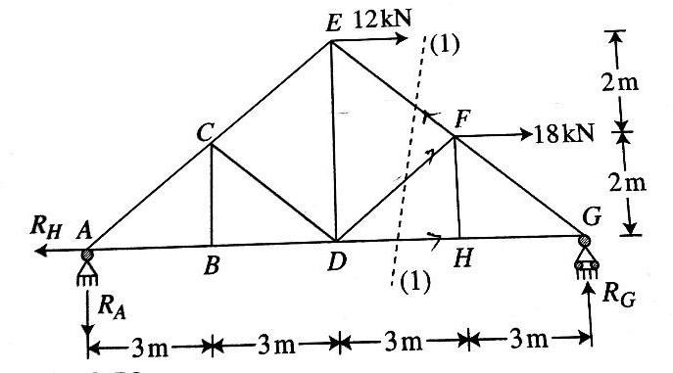

Evaluate the forces in members FE and CE of the truss as shown in the figure by using methods of section methods (dec 2017)
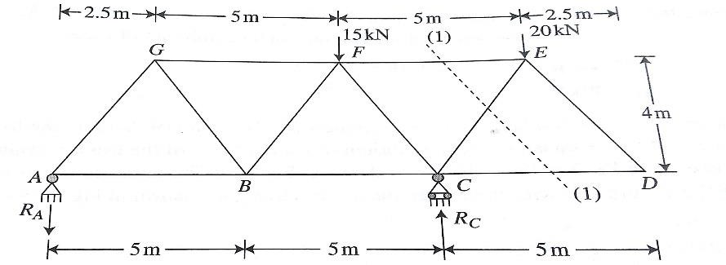
Analyze the frame shown in the figure by using method of tension coefficients. (may 2018)
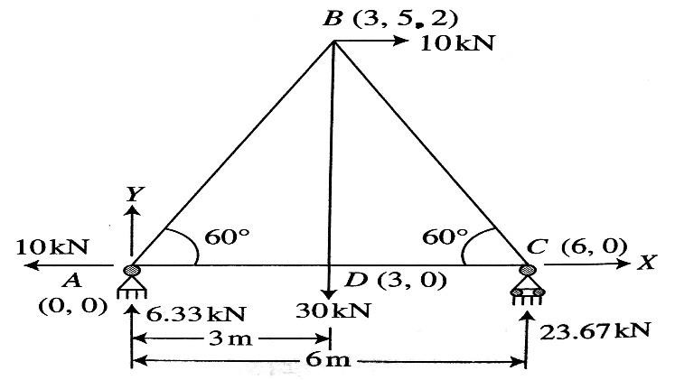
Determine the forces in truss as shown in the figure which is subjected to inclined loads by method of joints (dec 2017)
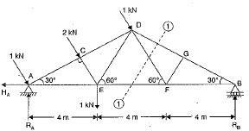

CHOOSE THE CORRECT ANSWER

- How many equilibrium equations do we need to solve generally on each joint of a truss?
a) 1
b) 2
c) 3
d) 4
- If a member of a truss is in compression, then what will be the direction of force that it will apply to the joints?
a) Outward
b) Inward
c) Depends on case
d) No force will be there
- If a member of a truss is in tension, then what will be the direction of force that it will apply to the joints?
a) Outward
b) Inward
c) Depends on case
d) No force will be there
- What should be ideally the first step to approach to a problem using method of joints?
a) Draw fbd of each joint
b) Draw fbd of overall truss
c) Identify zero force members
d) Determine external reaction forces
- What should be the angle (in degrees) in the given system (part of a bigger system) if both of the members have to be a zero force member?
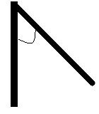
a) 22.5
b) 45
c) 67.5
d) 90
- 6.. Portal frames are frequently used in a building to:-
a) Transfer vertical forces
b) Transfer moment
c) Transfer horizontal forces
d) It is a zero it is used to transfer horizontal force applied at top of frame to foundation
  - 7.. Which of the following supports are not used in portals?
a) Fixed
b) Pin
c) partial
d) Roller
    - 8.. What is the degree of indeterminacy of a pin supported portal frame?
a) 1
b) 2
c) 3
d) 4
  - .
  - 9.. Where is point of inflection located in top girder in a pin supported portal frame?
a) At one of the ends
b) At both ends
c) At center of beam
d) Inflection point is not present

- 10What is the relation between shear at the base of each columns of a portal frame which is pin supported?
a) They are equal
b) One is double of other
c) One is triple of other
- d) Depends upon magnitude of load applied
FILLING THE BLANKS
- What is the simplest element of a space truss tetrahedron
- How many equations are solved per joints while solving space trusses three
- If, in the above question R= 7 then the truss are statically indeterminate
- If, in the above question R= 5 then the truss is unstable
- What is the degree of freedom of space roller join one
- According to assumptions, which type of joints are used in space truss ball and socket
- For the validity of principle of superposition, materials should behave in which manner linear elastic
- If in planar system, X parts/members are there with Y no. of forces, then condition for statically determinacy is y=3x
- If in a planar system, only 2 reaction forces are acting, then the system is essentially unstable
- If a structure has total 10 joints, then what should be the minimum no. of joints in which equilibrium equations should be concurrently satisfied for stability 10

